

**INSTITUTE OF AERONAUTICAL ENGINEERING**

**(Autonomous)**

# **Dundigal, Hyderabad – 500 043, Telangana**

# 

# 

# **TWO WEEK SUMMER INTERNSHIP**

**ON**

**MITIGATING COVID-19 TRANSMISSION IN SCHOOLS WITH DIGITAL**

**CONTACT TRACING**

**BY**

**MACHA VASANTH**

**20951A12B1**

# **INFORMATION TECHNOLOGY**

**UNDER THE GUIDENCE**

**OF**

**Mr. PHANI KRISHNA**



**INDEX**

1. Abstract
2. Brief Introduction
3. Existing system
4. Proposed system
5. Introduction
6. Introduction to Digital Contact Tracing
7. Importance of Digital Contact Tracing
8. Significance of Machine Learning in Mitigating Covid-19 Transmission in schools with digital contact tracing
9. Data Collection and Pre-processing
10. Feature Selection and Feature Engineering Techniques
11. Architecture Diagram
12. Use Case Diagram
13. Class Diagram and Data Flow Diagram
14. Flow Chart: Remote User & Service Provider
15. Sequence Diagram
16. Feasibility Analysis
17. System Design and Development
18. Modules
19. Data Description and Epidemic Models
20. Mitigation Strategies
21. Experiment Results
22. Conclusion
23. References

# 



# Abstract

Precision mitigation of COVID-19 is in pressing need for post pandemic time with the absence of pharmaceutical interventions. In this study, the effectiveness and cost of digital contact tracing (DCT) technology-based on-campus mitigation strategy are studied through epidemic simulations using high-resolution empirical contact networks of teachers and students. Compared with traditional class, grade, and school closure strategies, the DCT-based strategy offers a practical yet much more efficient way of mitigating COVID-19 spreading in the crowded campus. Specifically, the strategy based on DCT can achieve the same level of disease control as rigid school suspensions but with significantly fewer students quarantined. We further explore the necessary conditions to ensure the effectiveness of DCT-based strategy and auxiliary strategies to enhance mitigation effectiveness and make the following recommendation: social distancing should be implemented along with DCT, the adoption rate of DCT devices should be assured, and swift virus tests should be carried out to discover asymptomatic infections and stop their subsequent transmissions. We also argue that primary schools have higher disease transmission risks than high schools and, thereby, should be alerted when considering reopening’s.

**Keywords:** Asymptomatic infection, COVID-19, digital contract tracing, mitigation strategy, social distancing, susceptible-exposed-infectious-removed (SEIR)

# I. Introduction

The COVID-19 pandemic has emerged into a global threat and was pseudonymously linked to more than 16 million and 600 thousand COVID-19-related cases and deaths as of July 2020 albeit a mass of social distancing orders that have been enacted worldwide. In the absence of pharmaceutical interventions, measures to reduce the overall burden of viral infection —including social distancing, case isolation, quarantine of susceptible, closure of public places, and increased availability of diagnostics—are paramount in planning for the months ahead. Given the epidemiological disparity of strategies with the substantial economic and societal costs to sustain the virus transmission, there is a clear need for precision mitigation to alleviate the persistent burden of epidemics and prevent and respond effectively to future pandemics.



Mass education is an indispensable foundation of modern society. Nevertheless, schools and universities, where teachers and students have long-term and intimate connections, are particularly risky areas for disease transmission. To prevent campus outbreak, school suspension and closure of classes and grades are generally considered feasible approaches that can effectively reduce the number of infections. However, school suspension or parts thereof can also result in a large number of students quarantined, either concentrated or at home, causing substantial socioeconomic costs and psychological problems. Therefore, the critical question in effective retention lies in the selection of an effective mitigation strategy while in listing a minimum cost to the society and economy.



Since large-scale human experiments with disease control measures are costly and risky to conduct, mathematical modelling offers a viable way to examine the impact of these measures with varying rates of controls . Traditional transmission models are built upon mechanistic ones, such as the susceptible-infectious-removed (SIR) or susceptible-exposed-infectious-removed (SEIR) models. However, the parameter settings of the models can vary among different diseases. Recently, animal experiments on cynomolgus macaques inoculated with the severe acute respiratory syndrome coronavirus 2 (SARS-CoV-2) have shown that the virus shedding can be PR symptomatic and volatile . Based on this finding, we propose an SEIR model with a variable infection rate that takes into account the frequent shift of SARS-CoV-2 from infections hence their transmissibility.

Except for the realistic transmission model, realistic assumptions, such as the accurate demographic data of a specific scenario, are also the prerequisite of epidemic modelling with validating results. The realistic demographic assumption mainly relies on high-resolution human interaction data. Common ways of acquiring such data include radio frequency identification devices (RFID) tracing, GPS tracing, Wi-Fi hotspot sharing, and other proximity traces, such as student card presences. In this study, we use two empirical data sets of wearable RFID devices’ proximity collected from a primary school and high school, to construct temporal networks of campus interactions. The spatial proximity of two RFID devices resembles a close contact scenario that most probably facilitates the COVID-19 transmission.

Digital contact tracing (DCT) is a new and valuable technology based on mobile applications to understand the routes and timings of transmission. Tracing devices, e.g., mobile phones or RFID, can log their mobility or close contacts with other devices so that wearers can monitor their virus exposure in a timely fashion. Many governments have used smartphone contact tracing apps to automate the difficult task of tracing all recent contacts of newly identified infected individuals. Researchers have verified the effectiveness of DCT by constructing a contact network of 115 students at a certain university or setting a model of individual level transmission based on 40 162 participants. At present, there are few DCT studies on the cluster environment, and considering the easiness of technology adoption, this method can potentially provide a cost-effective solution to early detection, case isolation, and outbreak prevention of COVID-19 in certain environments where the population density is high, such as on campus.



In this study, we examine the effectiveness and cost of several mitigation strategies on campus, including the ones that utilize the newly proposed DCT technology. The effectiveness is measured by the number of infected students and the cost of the quarantined students. Compared with traditional suspension and closure methods, the DCT-based quarantine strategy can control disease-spreading much more efficiently. Necessary conditions for ensuring the DCT-based strategy’s effectiveness and possible auxiliary strategies that provide further enhancement are also explored, including the social distancing strategy, the DCT device adoption rate, the influence of community infections, and the asymptomatic infections in the population. The results obtained from this study are expected to significantly impact the making of school policies in the post-pandemic era.

The rest of this article is organized as follows. Section II describes the student and teacher contact data sets, constructs temporal contact networks, proposes the COVID-19 variable infection model, and demonstrates disease spreading in the real-life network without mitigation measures. Section III discusses several mitigation strategies, including the closure of classes and grades, as well as one that is based on DCT, and their potential interventions to our proposed model. Section IV demonstrates the effectiveness and cost of different mitigation strategies, considering influences from further external factors, such as the proportion of asymptotic infections, the influences of social distancing and community infections, and the DCT device adoption rate in schools. Section V concludes this study.

**EXISTING SYSTEM**

* Reopening schools is an urgent priority as the COVID-19 pandemic drags on. To explore the risks associated with returning to in-person learning and the value of mitigation measures, we developed stochastic, network-based models of severe acute respiratory syndrome coronavirus 2 (SARS-CoV-2) transmission in primary and secondary schools.



* The existing system find that a number of mitigation measures, alone or in concert, may reduce risk to acceptable levels. Student cohering, in which students are divided into two separate populations that attend in-person classes on alternating schedules, can reduce both the likelihood and the size of outbreaks. Proactive testing of teachers and staff can help catch introductions early, before they spread widely through the school. In secondary schools, where the students are more susceptible to infection and have different patterns of social interaction, control is more difficult.



* Especially in these settings, planners should also consider testing students once or twice weekly. Vaccinating teachers and staff protect these individuals and may have a protective effect on students as well. Other mitigations, including mask wearing, social distancing, and increased ventilation, remain a crucial component of any reopening plan.

Disadvantages

1) . There is no Digital contact tracing (DCT) which is a new and valuable technology based on mobile applications to understand the routes and timings of transmission.

2). There is no Transmissibility of Different Infection Models.

**PROPOSED SYSTEM**

* Digital contact tracing (DCT) is a new and valuable technology based on mobile applications to understand the routes and timings of transmission [28]. Tracing devices, e.g., mobile phones or RFID, can log their mobility or close contacts with other devices so that wearers can monitor their virus exposure in a timely fashion. Many governments have used smartphone contact tracing apps to automate the difficult task of tracing all recent contacts of newly identified infected individuals [30]. Researchers have verified the effectiveness of DCT by constructing a contact network of 115 students at a certain university or setting a model of individual-level transmission based on 40 162 participants



* At present, there are few DCT studies on the cluster environment, and considering the easiness of technology adoption, this method can potentially provide a cost-effective solution to early detection, case isolation, and outbreak prevention of COVID-19 in certain environments where the population density is high, such as on campus.



* In this study, the system examines the effectiveness and cost of several mitigation strategies on campus, including the ones that utilize the newly proposed DCT technology. The effectiveness is measured by the number of infected students and the cost of the quarantined students. Compared with traditional suspension and closure methods, the DCT-based quarantine strategy can control disease-spreading much more efficiently. Necessary conditions for ensuring the DCT-based strategy’s effectiveness and possible auxiliary strategies that provide further enhancement are also explored, including the social distancing strategy, the DCT device adoption rate, the influence of community infections, and the asymptomatic infections in the population. The results obtained from this study are expected to significantly impact the making of school policies in the post-pandemic era.

**Advantages**

* The system more effective due to Quarantine Strategy Based on Digital Contact Tracing techniques.
* The gives accurate results due to presence of Epidemic Model With Variable Infection Rate.

**Importance of Digital Contact Tracing**

Digital contact tracing can indeed be a valuable tool in mitigating COVID-19 transmission in schools. By using technology to track and monitor interactions among students and staff, schools can identify potential exposure to the virus and take swift action to prevent further spread. Here are some key points to consider when implementing digital contact tracing in schools:



1. Mobile Applications: Utilize mobile applications specifically designed for contact tracing. These apps can use Bluetooth or GPS technology to identify close contacts between individuals within a certain proximity.



2. Privacy Considerations: Ensure that privacy concerns are addressed when implementing digital contact tracing. Choose solutions that prioritize data security and anonymity, while adhering to relevant privacy laws and regulations.

3. Voluntary Participation: Make participation in digital contact tracing voluntary for students and staff. Encourage individuals to understand the benefits and opt-in willingly, emphasizing that it is a collective effort to keep the school community safe.

4.Education and Awareness: Provide comprehensive information about the purpose and benefits of digital contact tracing. Educate students, staff, and parents about how the system works, the importance of accurate data input, and the measures taken to protect privacy.

5.Proactive Reporting: Encourage students and staff to promptly report any symptoms or positive test results. This will help ensure accurate contact tracing and allow for timely interventions to prevent further transmission.

6.Quick Response: Establish a clear protocol for responding to potential exposures. When digital contact tracing identifies a close contact or potential outbreak, notify the affected individuals promptly and provide guidance on testing, isolation, and quarantine measures.

7.Data Analysis and Insights: Leverage the data collected through digital contact tracing to gain insights into transmission patterns within the school community. This information can aid in implementing targeted interventions, such as adjusting classroom layouts, modifying schedules, or strengthening hygiene protocols in specific areas.

8.Collaboration with Health Authorities: Work closely with local health authorities and public health experts to align digital contact tracing efforts with broader community initiatives. Collaborative efforts can enhance the effectiveness of contact tracing and ensure a coordinated response to outbreaks.

9.Ongoing Evaluation and Improvement: Continuously assess the effectiveness of digital contact tracing in the school setting. Solicit feedback from stakeholders, monitor outcomes, and make necessary adjustments to improve the system's accuracy, efficiency, and acceptance.



It's important to note that while digital contact tracing can be a valuable tool, it should be implemented as part of a comprehensive set of measures to prevent COVID-19 transmission in schools. These measures may include mask-wearing, hand hygiene, physical distancing, improved ventilation, and vaccination of eligible individuals.

**Significance of Machine Learning in mitigating COVID-19 transmission in schools with digital contact tracing**

Machine learning plays a significant role in mitigating COVID-19 transmission in schools through digital contact tracing. Here's an overview of how machine learning is utilized in this context:

1.Data Analysis: Machine learning algorithms can analyse large volumes of data collected through digital contact tracing to identify patterns and trends. These algorithms can uncover insights about transmission dynamics, high-risk areas, and factors contributing to the spread of the virus within the school environment.

2.Contact Identification: Machine learning models can assist in identifying close contacts by analysing data from mobile applications or other contact tracing tools. These models can determine the proximity and duration of interactions between individuals, helping to accurately identify potential exposures.

3.Risk Assessment: Machine learning algorithms can assess the risk level associated with different contacts or interactions. By considering factors such as proximity, duration, and the health status of individuals involved, these algorithms can provide a risk score that helps prioritize contact tracing efforts and intervention strategies.

4.Outbreak Prediction: Machine learning can contribute to early detection of potential outbreaks within schools. By analysing data on symptoms, test results, and contact tracing information, predictive models can identify emerging clusters or trends that indicate a higher risk of transmission. This enables proactive measures to be implemented promptly.

5.Resource Allocation: Machine learning algorithms can optimize resource allocation by predicting the number of potential cases or identifying areas with a higher probability of transmission. This information can guide decisions on testing, isolation, quarantine, and resource allocation, ensuring efficient utilization of available resources.



6.Real-time Monitoring: Machine learning models can continuously monitor and analyse incoming data from digital contact tracing systems, allowing for real-time updates on potential exposures and transmission risks. This enables timely responses and interventions to mitigate the spread of the virus within the school community.

7.Decision Support: Machine learning algorithms can provide decision support to school administrators, health authorities, and policymakers. By synthesizing and analysing complex data, these algorithms can assist in making informed decisions regarding school operations, preventive measures, and intervention strategies.

8.Model Improvement: As more data becomes available, machine learning models can be refined and improved. By incorporating new insights and data patterns, these models can adapt to evolving circumstances and enhance the accuracy and effectiveness of contact tracing efforts over time.

It's important to note that machine learning algorithms are only as good as the data they are trained on. Therefore, ensuring high-quality and reliable data collection is crucial for the successful implementation of machine learning in digital contact tracing for COVID-19 transmission mitigation in schools.

**Data collection and pre-processing are essential steps in mitigating COVID-19 transmission in schools through digital contact tracing. Here's an overview of the process:**

1.Data Collection Methods: Schools can collect data through various methods, including mobile applications, wearable devices, or digital sign-in systems. These systems can record information such as the identities of individuals, timestamps of interactions, location data, and symptom reporting.

2.Data Privacy and Consent: It is crucial to prioritize data privacy and obtain appropriate consent from individuals participating in digital contact tracing. Ensure that data collection and storage comply with relevant privacy laws and regulations. Communicate clearly with students, staff, and parents about the purpose of data collection, how it will be used, and the measures in place to protect their privacy.



3.Data Pre-processing: Raw data collected from different sources often require pre-processing before analysis. Pre-processing steps may include data cleaning to remove any errors or inconsistencies, data integration to merge information from different sources, and data anonymization to protect personal identities.



4.Data Integration: In a school setting, data may come from multiple sources, such as contact tracing apps, attendance records, and health assessments. Integrating these diverse datasets allows for a more comprehensive understanding of potential exposures and transmission patterns within the school community.

5.Data Quality Assurance: Ensure the quality and accuracy of the collected data. Implement validation processes to detect and handle missing, incomplete, or erroneous data. This may involve cross-checking data entries, verifying the accuracy of symptom reports, or validating the integrity of location and timestamp information.

6.Data Storage and Security: Establish secure data storage infrastructure to protect the collected data. Adhere to best practices for data security, encryption, access controls, and backups to prevent unauthorized access or data breaches.

7.Data Standardization: Standardize the format and structure of collected data to facilitate analysis and comparison. Consistent data formats enable machine learning algorithms to process and analyse the data effectively.

8.Data Analysis: Once the data has been pre-processed and standardized, it can be analysed using various techniques such as machine learning, statistical analysis, or visualization methods. These analyses can provide insights into transmission patterns, identify high-risk areas, and support decision-making for preventive measures.

9.Ongoing Data Maintenance: Continuously update and maintain the data as new information becomes available. Regularly check for data quality, ensure data integrity, and update contact information or health status as required.

Throughout the entire data collection and pre-processing process, it is essential to ensure compliance with applicable data protection regulations and ethical considerations. Safeguarding personal privacy and maintaining the security of collected data should be a top priority at all times.



**Architecture Diagram**

**Architecture Diagram**

Service Provider

Login,

Train & View Mitigating COVID19 Transmission,  
Find Mitigation of COVID19 Transmission Ratio,   
View All COVID19 Transmission Prediction,   
Download Trained Data Sets,   
View All Remote Users,   
View Mitigation of COVID19 Transmission Ratio Results,   
View Mitigation of COVID19 Transmission Ratio in Bar Charts,   
View School Children Oxigen Results,  
Remote User.

Accepting all user Information

**Admin**

View user data details

Authorize the Admin

Process all user queries

**Store and retrievals**

**WEB Database**

Registering the User



Remote User

Tweet Server

Tweet Server

Tweet Server

REGISTER AND LOGIN,

POST SCHOLL DATA SETS,

PREDICT MITIGATION OF COVID19 STATUS,

VIEW YOUR PROFILE.

* **Use case**

Service Provider

**Remote User**

 



* **Class Diagram:**

Login, Register

User Name, Password

Service Provider

Login, Train & View Mitigating COVID19 Transmission, Find litigation of COVID19 Transmission Ratio, View All COVID19 Transmission Prediction, Download Trained Data Sets, View All Remote Users, View Mitigation of COVID19 Transmission Ratio Results, View Mitigation of COVID19 Transmission Ratio in Bar Charts, View School Children Oxygen Results, Remote User.

Scholl_Code,names,Scholl_Type,Function,Contact_Name,Address,Town,Zip,Phone,Number_Of_Children,Oxigen_level,Fever,Mitigating_Status.

Methods

Members

**Login**

**Register**

Register (), Reset ()

User Name, Password, E-mail, Mobile, Address, DOB, Gender, Pin code, Image

Login (), Reset (), Register ().

User Name, Password.

Methods

Methods

Members

Members

Remote User

Tweet Servervvv

Tweet Server

Tweet Server

Tweet Server

Tweet Server



REGISTER AND LOGIN,

POST SCHOLL DATA SETS,

PREDICT MITIGATION OF COVID19 STATUS,

VIEW YOUR PROFILE.

Scholl_Code,names,Scholl_Type,Function,Contact_Name,Address,Town,Zip,Phone,Number_Of_Children,Oxigen_level,Fever,Mitigating_Status.



Methods

Members

* **Data Flow Diagram**:

Remote User

Tweet Server

Tweet Server

Tweet Server

Tweet Server

Tweet ServerTweet Server

Tweet Server

Response

System

Request

Service Provider



* **Flow Chart: Remote User**

Login

Start

Status

Yes No

Username & Password Wrong

REGISTER AND LOGIN

Register and Login

Register and Login

POST SCHOLL DATA SETS,

PREDICT MITIGATION OF COVID19 STATUS,

VIEW YOUR PROFILE

Logout



* **Flow Chart:** Service Provider
* **Flow Chart :** Service Provider

**Start**

**Login**

**Status**

Yes No

Train & View Mitigating COVID19 Transmission,

**Username & Password Wrong**

Find Mitigation of COVID19 Transmission Ratio,

**Log Out**

View All COVID19 Transmission Prediction,



Download Trained Data Sets,

View All Remote Users,

View Mitigation of COVID19 Transmission Ratio Results,

View Mitigation of COVID19 Transmission Ratio in Bar Charts,

View School Children Oxygen Results

View All Remote Users



* **Sequence Diagram**

Service Provider

Remote User

Web Server



REGISTER AND LOGIN

POST SCHOLL DATA SETS,

PREDICT MITIGATION OF COVID19 STATUS

VIEW YOUR PROFILE

Login,

Train & View Mitigating COVID19 Transmission,

Find Mitigation of COVID19 Transmission Ratio,

View All COVID19 Transmission Prediction,

Download Trained Data Sets,

View All Remote Users,

View Mitigation of COVID19 Transmission Ratio Results,

View Mitigation of COVID19 Transmission Ratio in Bar Charts,

View School Children Oxygen Results,

Remote User.



**SYSTEM DESIGN AND DEVELOPMENT**



**INPUT DESIGN**

Input Design plays a vital role in the life cycle of software development, it requires very careful attention of developers. The input design is to feed data to the application as accurate as possible. So inputs are supposed to be designed effectively so that the errors occurring while feeding are minimized. According to Software Engineering Concepts, the input forms or screens are designed to provide to have a validation control over the input limit, range and other related validations.

This system has input screens in almost all the modules. Error messages are developed to alert the user whenever he commits some mistakes and guides him in the right way so that invalid entries are not made. Let us see deeply about this under module design.

Input design is the process of converting the user created input into a computer-based format. The goal of the input design is to make the data entry logical and free from errors. The error is in the input are controlled by the input design. The application has been developed in user-friendly manner. The forms have been designed in such a way during the processing the cursor is placed in the position where must be entered. The user is also provided with in an option to select an appropriate input from various alternatives related to the field in certain cases.

Validations are required for each data entered. Whenever a user enters an erroneous data, error message is displayed and the user can move on to the subsequent pages after completing all the entries in the current page.

OUTPUT DESIGN

The Output from the computer is required to mainly create an efficient method of communication within the company primarily among the project leader and his team members, in other words, the administrator and the clients. The output of VPN is the system which allows the project leader to manage his clients in terms of creating new clients and assigning new projects to them, maintaining a record of the project validity and providing folder level access to each client on the user side depending on the projects allotted to him. After completion of a project, a new project may be assigned to the client. User authentication procedures are maintained at the initial stages itself. A new user may be created by the administrator himself or a user can himself register as a new user but the task of assigning projects and validating a new user rest with the administrator only.



The application starts running when it is executed for the first time. The server has to be started and then the internet explorer in used as the browser. The project will run on the local area network so the server machine will serve as the administrator while the other connected systems can act as the clients. The developed system is highly user friendly and can be easily understood by anyone using it even for the first time.

**Modules**

**Service Provider**

In this module, the Service Provider has to login by using valid user name and password. After login successful he can do some operations such as

Train & View Mitigating COVID19 Transmission, Find Mitigation of COVID19 Transmission Ratio, View All COVID19 Transmission Prediction, Download Trained Data Sets, View All Remote Users, View Mitigation of COVID19 Transmission Ratio Results, View Mitigation of COVID19 Transmission Ratio in Bar Charts, View School Children Oxygen Results, Remote User.

**View and Authorize Users**

In this module, the admin can view the list of users who all registered. In this, the admin can view the user’s details such as, user name, email, address and admin authorize the users.

**Remote User**



In this module, there are n numbers of users are present. User should register before doing any operations. Once user registers, their details will be stored to the database. After registration successful, he has to login by using authorized user name and password. Once Login is successful user will do some operations like POST SCHOLL DATA SETS, PREDICT MITIGATION OF COVID19 STATUS, VIEW YOUR PROFILE.



# II. Data Description and Epidemic Models

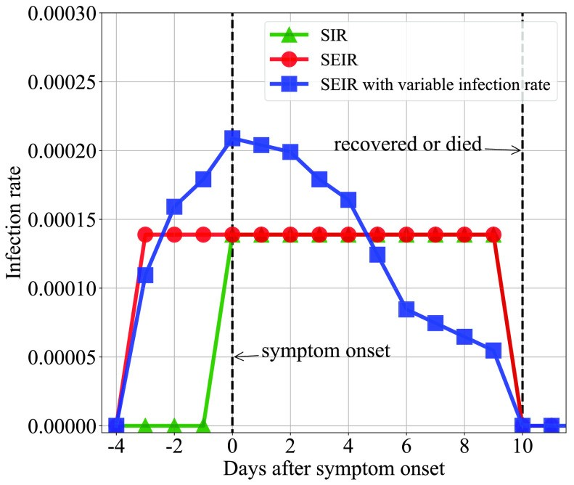

[Fig. 1.](https://www.ncbi.nlm.nih.gov/pmc/articles/PMC8843051/figure/fig1/)

Constant and variable infection rate models. The accumulative transmissibility of the variable SEIR and constant (SEIR) infection rate models, i.e., the areas under the red and blue lines, are the same.

## C. Transmissibility of Different Infection Models

As shown in [Fig. 2,](https://www.ncbi.nlm.nih.gov/pmc/articles/PMC8843051/figure/fig2/) our model significantly advances the epidemic peaks for several days compared to the SEIR model and enlarges the epidemic sizes when one happens. The SIR model, on the contrary, generates very few epidemics comparatively. The reason for such strong transmissibility of our proposed epidemic model is that infected individuals can be infectious for four days before being discovered than only one day in the SIR model. Meanwhile, the virus shedding volume surges on and before the symptom onset date. This result highlights the necessity of a swift mitigation measure for epidemic prevention to COVID-19 on campus.

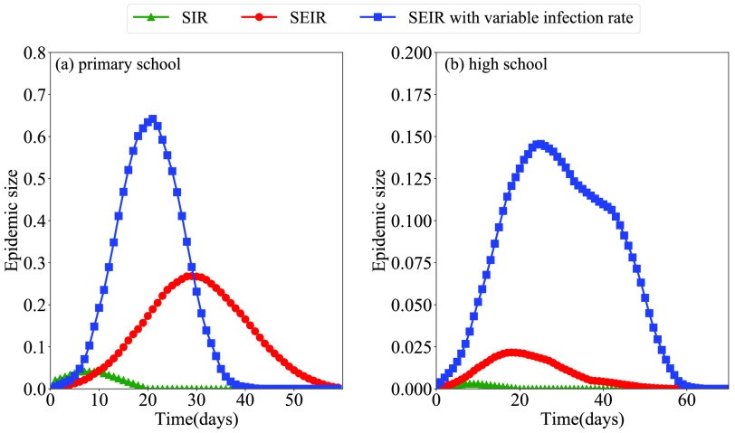

[Fig. 2.](https://www.ncbi.nlm.nih.gov/pmc/articles/PMC8843051/figure/fig2/)



Averaged epidemic spreading curves in (a) primary school and (b) high school using three different infection rate models. Day 0 represents the Monday of the first week.



# Mitigation Strategies

This study aims to examine the effectiveness and cost of the DCT-based mitigation strategy for COVID-19 spreading on campus. The effectiveness of a strategy is measured by the number of infections in the school. The cost is measured by the number of teachers and students isolated or quarantined. Traditional on-campus mitigation strategies, such as the temporary closure of classes, are employed as comparative measures.

## A. Traditional Mitigation Strategies

School suspension and closure of grades and classes are generally considered feasible control measures for epidemic spreading on campus but vary in their effectiveness and cost. Effective distance, which has been proven a feasible measure for evaluating the possibility of disease transmission between two individuals, especially for infectious respiratory viruses, such as H1N1 and SARS, can help comprehend the rationale behind these traditional mitigation strategies. The effective distance  between two individuals and in a contact, network is defined as



in which the contact probability is given as



where  represents the number of contacts between represents the total number of contacts of ranges from 1 to infinity. A short effective distance can accelerate virus spreading, while a large effective distance will hinder the spreading of infectious diseases.



and



, and



.



The effective distance matrices of the primary and high school teachers and students are shown in [Fig. 3.](https://www.ncbi.nlm.nih.gov/pmc/articles/PMC8843051/figure/fig3/) The primary school is composed of five grades, and each grade includes two classes, thus a total of ten classes. The high school is composed of four grades and a total of nine classes. In [Fig. 3,](https://www.ncbi.nlm.nih.gov/pmc/articles/PMC8843051/figure/fig3/) the darker the blue, the smaller the effective distance, and the more easily the virus spreads. It can be seen that students in the same class form a dark blue grid, and the effective distances are mostly shorter than 4, which means that the virus can more easily spread within a class. A red box represents a grade. In primary school, the contact is slightly closer in grades 1 and 3 and slightly sparser in grades 2, 4, and 5. In high school, although there are fewer contacts between classes, the connections with the same grade are still denser than between grades. That is to say, the virus can spread between classes in the same grade. Therefore, commonly used mitigation strategies for infectious diseases on campus with ascending rigidity and effectiveness involve the following.



1. *Case Isolation:* Whenever a student shows symptoms, they are isolated from the rest of the students for some time.
2. *Class Closure:* Whenever the number of symptomatic individuals in a class reaches a fixed threshold, the class is closed for some time;
3. *Grade Closure:* Whenever the number of symptomatic individuals in a grade reaches a fixed threshold, the grade is closed for some time;
4. *School Closure:* Whenever the number of symptomatic individuals in the school reaches a fixed threshold, the whole school is closed for some time.

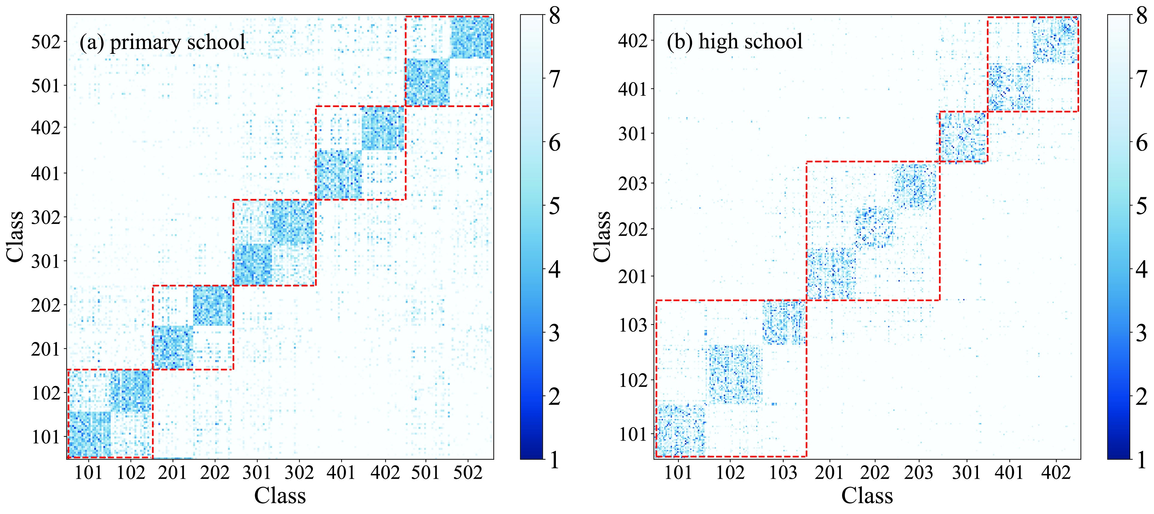

[Fig. 3.](https://www.ncbi.nlm.nih.gov/pmc/articles/PMC8843051/figure/fig3/)

Effective distance matrixes of (a) primary school and (b) high school. The labels on the axes indicate the grade and class to which the students belong, e.g., 201 means class 1 of grade 2.

Two key parameters control the intensity of a mitigation measure: the strategy trigger threshold, e.g., the number of symptomatic individuals detected, and the duration of the isolation or closure. This study considers the trigger threshold to be 1 and the isolation duration to be 14 days. For example, whenever a symptom onset is detected in a class, all the classmates must be quarantined for 14 days under the class closure strategy. Classes, grades, and schools can be closed again after reopening.



## B. Quarantine Strategy Based on Digital Contact Tracing

The traditional class and grade closure strategies, in which all the students within the same classes or grades are quarantined because of their assumptive close contact with the symptomatic individual, can be an overreaction: those who are forced to quarantine but had no direct exposure to the disease do not contribute to the epidemic mitigation yet lose their opportunity of normal education. In contrast, the DCT technology can precisely identify the most probable disease exposures.

Considering that any logged proximity between two individuals using DCT is a close contact regardless of duration, and any th order contacts of the initial infection can be traced back and send to quarantine, covering all their subsequent infections. DCT-based strategy’s mitigation effectiveness depends on the selection of . Given a single symptomatic infection in our model, the probability of their transmission range, i.e., the furthest order of neighbour that the disease reaches, is shown in [Fig. 4.](https://www.ncbi.nlm.nih.gov/pmc/articles/PMC8843051/figure/fig4/) Since the incubation period of the patient is four days, we consider the transmission range of the patient within four days. The primary school data set only includes the two days of school activities, so the result of four days is the same as that of two days, and we only show the transmission range of two days in the primary school.

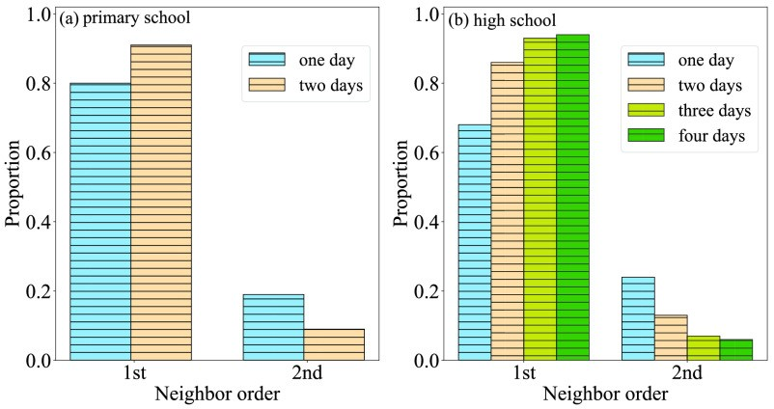

[Fig. 4.](https://www.ncbi.nlm.nih.gov/pmc/articles/PMC8843051/figure/fig4/)

Disease’s transmission range, i.e., furthest order of initial infection’s neighbour that it reaches, in (a) primary school and (b) high school.



In most cases, the disease only transmits for one generation and seldom over two generations. Therefore, we propose a mitigation strategy based on DCT that, whenever an infection is discovered, they and only their first-order close contacts in four days before the infections, who are discovered, should be quarantined. The quarantine time is also set to be 14 days, as same as in the traditional strategies. If teachers and students do not show symptoms after the quarantine, they return to the school.



# IV. Experimental Results

This section presents the effectiveness and cost of different mitigation strategies drawn from Monte Carlo simulations. The simulations were programmed with Python programming language and run on six-core CPUs, 32-GB memory space, and Windows 10 operating system. Each of the simulations runs 5000 times to encounter the randomness in the epidemic spreading process.

We used SEIR with variable infection rates for simulation. The simulations are run with three assumptions. First, only one infection is randomly placed at the beginning of each simulation. Second, if an individual is infectious, they can transmit the disease for the whole day. The contact duration between two individuals is accumulated by all their discrete contact periods on each day. Third, teachers and students are checked for symptoms at the end of each day. Only symptomatic individuals can be detected. Individuals in the incubation period or asymptomatic individuals cannot.

## A. Effectiveness and Cost of Mitigation Strategies

The effectiveness is measured by the number of infections, and the cost by the man time of quarantined individuals. We consider an epidemic being formed on campus whenever more than 10% of the teachers and students are infected. [Table I](https://www.ncbi.nlm.nih.gov/pmc/articles/PMC8843051/table/table1/) shows the epidemic probabilities

, i.e., the proportion of simulations that lead to epidemics, under each mitigation strategy and the median numbers  of teachers and students quarantined in both schools.



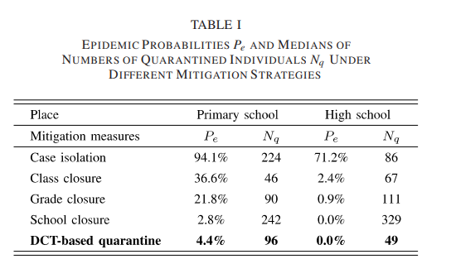



As the level of closure order escalates, the probability of an epidemic decreases. With only case isolation, i.e., no mitigation measure is taken, more than 94.1% and 71.2% simulations lead to epidemics in the primary and high schools, respectively. The DCT-based quarantine strategy can achieve the same levels of control as school suspension but with significantly smaller numbers of quarantined individuals.

[Table II](https://www.ncbi.nlm.nih.gov/pmc/articles/PMC8843051/table/table2/) shows the precision, i.e., the proportion of total infected individuals to total quarantined individuals under each measure, and the recall, i.e., the proportion of total infected individuals in quarantine to total infected individuals. We calculate precision and recall when implementing measures for the first time. Although the precision of case isolation is 100%, the recalls in primary school and high school are only 18% and 30%. After the first isolation, 82% or 70% of cases still spread the virus in schools. In primary school, the precision of DCT is lower than class and grade closures because the students have more first-order neighbours. The situation in high school is the opposite. In both schools, the precision of the DCT measure is higher than school closure, and the recall is higher than class and grade closures, with a value of over 90%. Considering that the disease is most transmissible between close contacts, DCT can precisely identify the most probable individuals rather than brutally shutting down the whole school. However, the DCT-based strategy’s effectiveness is still lower than school suspension, as there is still a certain probability that the disease can spread to the initial infections’ second-order contacts with four days of transmission.



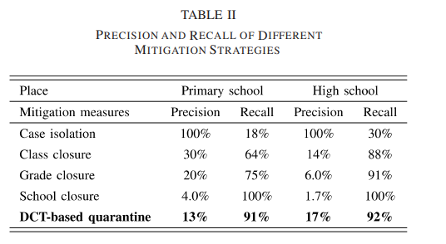



Mitigation strategies can not only decrease the epidemic probability but also lowers the epidemic size when one happens, although with variable effectiveness. We de Ine epidemic size as the proportion of infected teachers and students in a school when an epidemic occurs. [Fig. 5](https://www.ncbi.nlm.nih.gov/pmc/articles/PMC8843051/figure/fig5/) shows the averaged epidemic curves under different mitigation strategies. In primary school and high schools, the peak values of case isolation are 0.6 and 0.14, respectively. The results are significantly different from the other three measures. To better illustrate the differences between the other three measures, we did not add this curve in [Fig. 5.](https://www.ncbi.nlm.nih.gov/pmc/articles/PMC8843051/figure/fig5/) In both primary and high schools, class closure provides the lowest mitigation capability. The DCT-based quarantine can achieve similar results to school closure, which is the most rigid mitigation action and achieves the most substantial epidemic size reduction in both the primary and high schools.

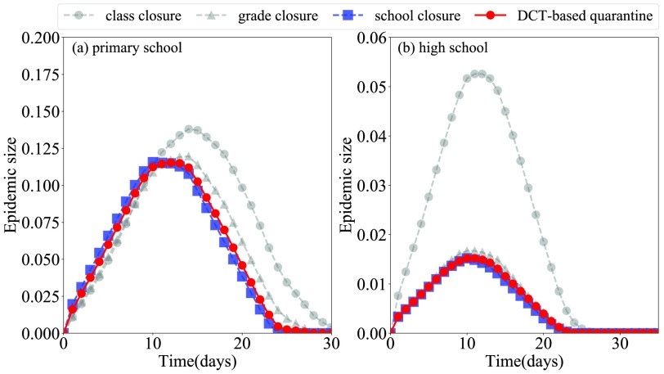

[Fig. 5.](https://www.ncbi.nlm.nih.gov/pmc/articles/PMC8843051/figure/fig5/)

Averaged epidemic spreading curves in (a) primary school and (b) high school under different mitigation strategies.



## B. Influence of Social Distancing



The epidemic probability and size in primary school are notably higher and larger than in high school. The reason is that the density (i.e., the average number of individuals’ contacts) and the intensity (i.e., the duration of close contacts among teachers and students) of the primary school contact network are different from those in the high school contact network. [Fig. 6](https://www.ncbi.nlm.nih.gov/pmc/articles/PMC8843051/figure/fig6/) shows the distributions of first- and second-order neighbours in the primary and high schools. In primary school, almost every pair of pupils can be connected within two hops, while, in high school, students are more sparsely connected.

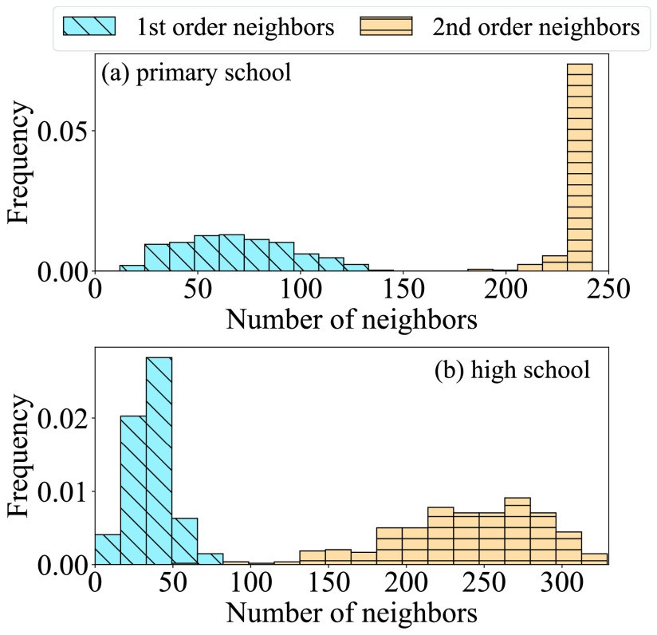

[Fig. 6.](https://www.ncbi.nlm.nih.gov/pmc/articles/PMC8843051/figure/fig6/)

Distributions of individuals’ numbers of first- and second-order neighbours in both (a) primary school and (b) high school.

If one can reduce the density and intensity of a contact network, naturally, the epidemic can be better controlled. Social distancing policies, e.g., calling off social gathering events and wearing masks, are feasible yet easy-to-implement nonpharmaceutical measures to lower the network density and reduce the contact intensity. Here, we evaluate the impact of additional social distancing policies enforced alongside the DCT-based mitigation strategy.



Edges in the contact networks are randomly removed to mimic the scenario of calling off social gathering events. The contact duration, i.e., the weight of the contact networks, is proportionally reduced to mimic the scenarios, such as reduced social activities. The influence of social distancing policies on the epidemic probability and size in both schools is shown in [Fig. 7.](https://www.ncbi.nlm.nih.gov/pmc/articles/PMC8843051/figure/fig7/) The epidemic size is the median of the cumulative number of cases in the simulations where the epidemic can occur. That is, the number of infected individuals is greater than 10% of the total number of students. The epidemic probability and sizes both decrease monotonically with the proportions of contacts removed and contact duration reduced. Epidemics can even be entirely prevented if social distancing is reduced to 10% of the normal level. Therefore, imposing social distancing policies can enhance the effectiveness of a DCT-based quarantine strategy.

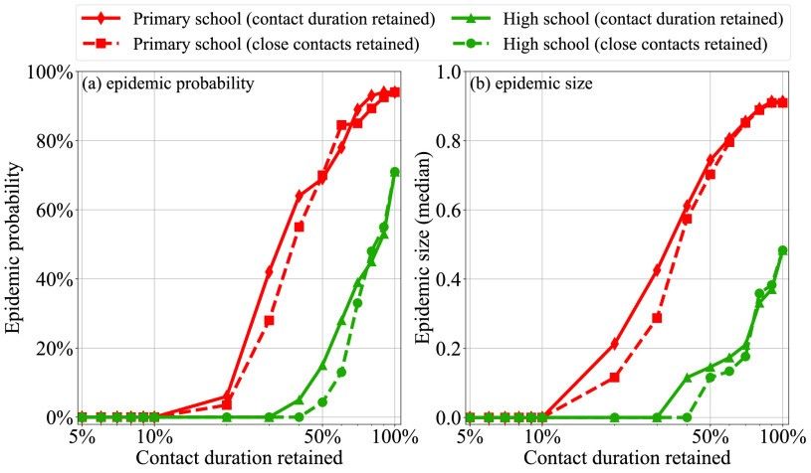

[Fig. 7.](https://www.ncbi.nlm.nih.gov/pmc/articles/PMC8843051/figure/fig7/)

Influence of social distancing on epidemic risks in both primary and high schools. (a) Epidemic probability and (b) epidemic size both increase monotonically with the proportion of contact duration retained.

## C. Influence of DCT Device Adoption Rate

To implement the DCT-based strategy, teachers and students have to wear RFID devices or install specific applications on their mobile phones. Although this method is proven to mitigate epidemics, it could, nonetheless, raise privacy concerns. Therefore, it is natural to assume that some teachers or students will not adopt this tracing technology. In this section, we analyse the impact of the adoption rate on this mitigation action.

[Fig. 8](https://www.ncbi.nlm.nih.gov/pmc/articles/PMC8843051/figure/fig8/) shows the changes in epidemic probability and size with the DCT device adoption rate. The higher the adoption rate, the less probable that an epidemic forms on campus. Note that the epidemic probability sharply decreases when the adoption rate is greater than 50% in primary school and 25% in high school, respectively. The epidemic size also decreases with the adoption rate, from close to 0.8, with less than 25% adoption rate to around 0 with 100% adoption rate, in both the primary and high schools. In light of these results, we recommend that, if schools adopt a DCT-based strategy for epidemic control, it must be implemented with continuous monitoring to ensure its effectiveness.

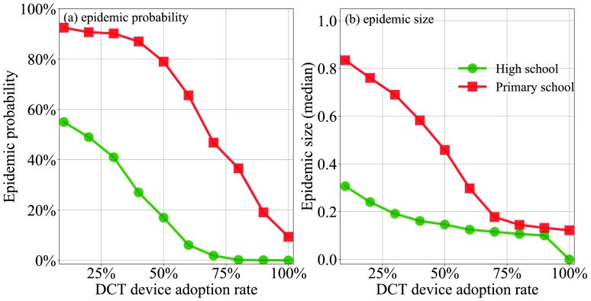

[Fig. 8.](https://www.ncbi.nlm.nih.gov/pmc/articles/PMC8843051/figure/fig8/)

Influence of DCT device adoption rate on (a) epidemic probabilities and (b) epidemic sizes.

## D. Influence of Community Infections

In the previous scenarios, we assume that the only infection source is the one incorporated into the model on day 0. However, considering that the teachers and students can also be exposed to hazardous environments after school, we introduce community infections into the model.

Specifically, an individual in a susceptible state has a probability of being infected at home or other social events. Depending on the community infection rate, variable numbers of infections can be introduced into our model each day. [Fig. 9](https://www.ncbi.nlm.nih.gov/pmc/articles/PMC8843051/figure/fig9/) shows the epidemic probability in both the primary and high schools with variable community infection probabilities. When the community infection probability is larger than 0.01, i.e., approximately one infection can be introduced each day or two, the epidemic probability sharply increases. However, the DCT-based quarantine strategy still outperforms the closure of classes and grades and close to school suspension.

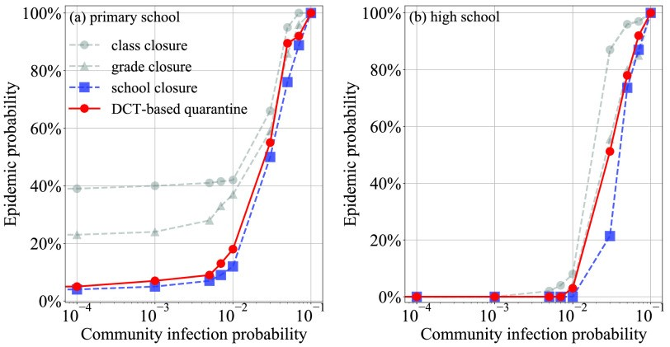

[Fig. 9.](https://www.ncbi.nlm.nih.gov/pmc/articles/PMC8843051/figure/fig9/)

Influence of community infection probability to the mitigation effectiveness in (a) primary school and (b) high school.

In the light that infections introduced externally can severely jeopardize the mitigation effectiveness of any strategy, schools should be always be alerted and prevent any imported infections from outside of campus.

## E. Influence of Asymptomatic Infections

Asymptomatic infections are infections that do not show any symptoms and, therefore, cannot be discovered with naked eyes without nucleic acid tests. Therefore, the virus transmission period of the asymptomatic infections can be 14 days rather than four days for symptomatic infections for COVID-19. In this analysis, we tune the proportion of asymptomatic infections in our model and analyse their impact on the effectiveness of mitigation strategies. Note that the disease transmissibility’s of symptomatic individuals and asymptomatic individuals are considered the same.

An individual can be set as asymptomatic with probability  and symptomatic with probability . The epidemic probabilities under all mitigation strategies with different asymptomatic probabilities  are shown in [Fig. 10](https://www.ncbi.nlm.nih.gov/pmc/articles/PMC8843051/figure/fig10/). The result of primary school shows that the epidemic probability can increases with almost linearly. In high school, the epi-

demic probability increases with  only when is greater than 10%. The reason is that there is less contact between high school students. Even if there are asymptomatic patients, the probability that the patients can infect others is lower, and the number of asymptomatic patients is relatively small when  is less than 10%.

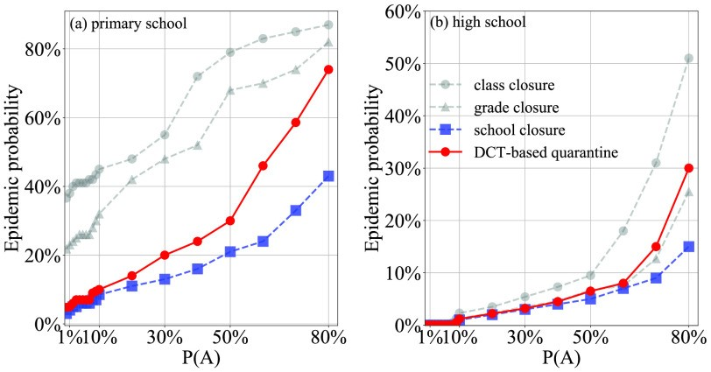

[Fig. 10.](https://www.ncbi.nlm.nih.gov/pmc/articles/PMC8843051/figure/fig10/)

Influence of asymptomatic infections to the mitigation effectiveness in (a) primary school and (b) high school.

is greater than 10%, the epidemic probability of the two schools can increase as

increases, and when  is high, the virus can spread to the second-order neigh-

When



bores, so the effect of first-order DCT is relatively weak. It should be noted that the prevention and control effect of grade closure is weak in primary school but effective in high school. When  is greater than 60%, the prevention and control effect of grade closure is even better

than DCT. This is because there is almost no contact between students of different grades in high school, and the virus is difficult to spread to other grades. Therefore, even if there are asymptomatic patients, closed grades have a strong effect in high school.

In summary, considering that  of COVID-19 can range from 10% to 80%, epidemics can easily happen in the presence of asymptomatic infections. Therefore, before the outbreak of the epidemic, students should be encouraged to wear masks or maintain social distancing to reduce the spread of the virus. Whenever a case is detected, strict virus testing methods, such as nucleic acid or serum testing, are encouraged to avoid epidemics. In the implementation of DCT, second-order neighbour tracking can also be considered.



**Results**





Fig1: background

 

Fig2 : login Fig3: Register

Output: <https://github.com/machavasanth/Mitigating-covid-19-transmission>

# V. Conclusion and Discussion

**CONCLUSIONS**

DCT with wearable hardware is a new and effective epidemic mitigation strategy that could be used to fight against highly infectious diseases, such as COVID-19. In this study, we proposed to examine its effectiveness and cost, quantified by the numbers of infections and quarantined individuals, respectively, in controlling disease spreading on campus. Two empirical high-resolution on-campus interpersonal close contact data sets and a modified SEIR model with a variable infection rate setting are employed to simulate epidemics. Compared to traditional mitigation strategies, such as the closure of classes, grades, and the whole school, the DCT quarantine strategy can achieve a similar effect as more rigid strategies but with a much smaller cost. Several factors can strongly affect the mitigation effectiveness of the DCT-based strategy. First when the probability of asymptomatic is high, the prevention and control effects of various strategies will be weakened as they can transmit the disease for an extended period than symptomatic infections, who are isolated as soon as they show any symptom. Second, community-introduced infections can jeopardize the efforts made by any mitigation strategy. Third, the adoption rate of teachers and students profoundly affects the effectiveness of the DCT-based strategy. Fourth, social distancing can help with the mitigation strategy and further increase its effectiveness.



In light of the above results, we make the following recommendations to the on-campus mitigation of COVID-19. First, a DCT-based strategy is encouraged in schools. Second, the strategy’s adoption rate must be monitored and assured continuously. Third, whenever an infection is detected on campus, rigid virus testings must be carried out to a larger extent of the population for asymptomatic or community introduced case discovery. Fourth, social distancing measures must be placed in schools to minimize the probability of disease spreading.

Note that the density of the primary school empirical contact network is much higher than that in the high school. Although the contact data are collected from two individual schools in a particular period, we argue that this phenomenon can be universal, as pupils in primary schools are more physical activity-intensive (i.e., having more physical contacts) than students in the high schools, who are in contrast more academic activity-intensive. Therefore, we warn that primary schools have a higher risk than high schools in disease transmission, thereby less suitable for pushing school reopens.



# References



______________________________________________________________________________________________



[1] M. Peng, “Outbreak of COVID-19: An emerging global pandemic threat,” *Biomed. Pharmacotherapy*, vol. 129, Sep. 2020, Art. no. 110499.

[2] G. Mohler *et al.*, “Impact of social distancing during COVID-19 pandemic on crime in loss Angeles and Indianapolis,” *J. Criminal Justice*, vol. 68, May 2020, Art. no. 101692.

[3] T. P. B. Thu, P. N. H. Ngoc, N. M. Hai, and L. A. Tuan, “Effect of the social distancing measures on the spread of COVID-19 in 10 highly infected countries,” *Sci. Total Environ.*, vol. 742, Nov. 2020,

Art. no. 140430.

[4] B. Patterson *et al.*, “A novel chortling and isolation strategy for suspected COVID-19 cases during a pandemic,” *J. Hospital Infection*, vol. 105, no. 4, pp. 632–637, Aug. 2020.

[5] Q. Cui, Z. Hu, Y. Li, J. Han, Z. Teng, and J. Qian, “Dynamic variations of the COVID-19 disease at different quarantine strategies in Wuhan and mainland China,” *J. Infection Public Health*, vol. 13, no. 6, pp. 849–855, Jun. 2020.

[6] M. Chan Sun and C. B. Lan Cheong Wah, “Lessons to be learnt from the COVID-19 public health response in Mauritius,” *Public Health Proact.*, vol. 1, Nov. 2020, Art. no. 100023.

[7] B. D. Singer, “COVID-19 and the next influenza season,” *Sci. Adv.*, vol. 6, no. 31, Jul. 2020, Art. no. eabd0086.

[8] R. E. Glover *et al.*, “A framework for identifying and mitigating the equity harms of COVID-19 policy interventions,” *J. Clin. Epidermoid.*, vol. 128, pp. 35–48, Dec. 2020.

